Expression of interest

Darwin and the Northern Territory
Australia’s Northern Territory, affectionately known by the locals as the Territory, is located on the doorstep to Asia. By area it is one-sixth of Australia’s land mass, and approximately 1% of Australia’s population. Two-thirds of all Territorians live in its capital Darwin and surrounds, on the margin of the Arafura Sea.
The Territory has space and lots of it, abundant and natural vistas and the world’s oldest culture.
To succeed the Territory has shown itself to be innovative, adaptive and ambitious seeking to make the most of its strategic advantages to grow its economy.
Darwin is a vibrant, multicultural city in the Territory’s tropical north. It offers a great lifestyle for residents and visitors alike, providing all things for all people whether your interests are in the great outdoors, sport, or cultural.
Darwin’s population is culturally diverse, well educated and welcoming. Come and join us.

The Northern Territory’s digital vision
Our vision is for the Territory to become Northern Australia’s most advanced digital economy and Australia’s digital gateway to Asia and beyond.
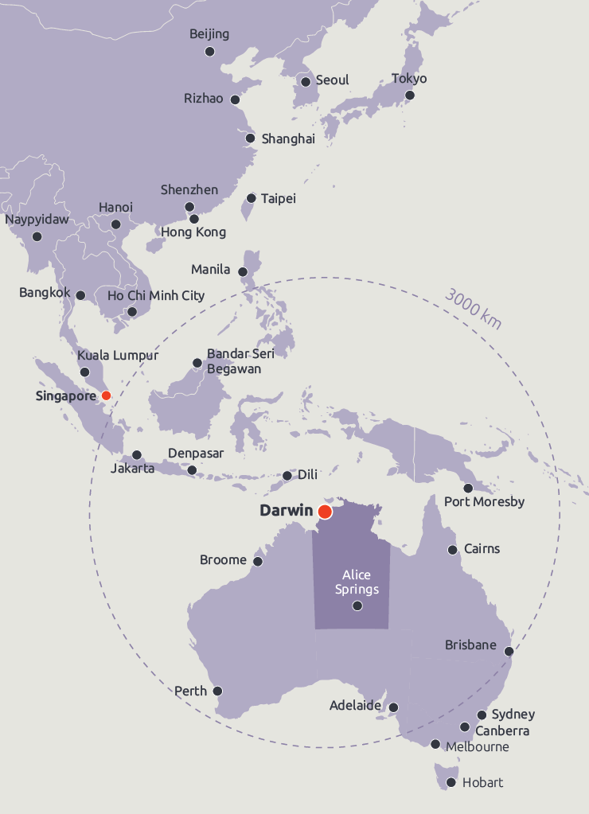

Darwin Data Centre opportunities
- Multiple planned routes to connect Darwin into a number of international low latency sub-sea cables that are at various stages of development
- Land costs are lower than other Australian capital cities
- It has a favourable Town Planning Scheme, with approvals timeframes of 10-12 weeks
- A cost of construction lower than that for Sydney
- Competitively priced power is achievable
- Access to concessional finance through the Northern Australia Infrastructure Facility
- Stable Government ensuring data sovereignty

Darwin connectivity
Planned sub-sea cables are at various stages of development and include:
- a new USA – Singapore cable with stub branching unit for connection to Darwin (Trans Pacific Cable)
- an interconnect between existing Australia Singapore Cable (ASC) and the North West Cable System (NWCS)
- new Fibre Expressway cable (Project Koete)
- new northern Australia – Timor-Leste cable to be funded by the Australian government
- new northern Australia – Kupang cable and subsequent linkage into an Indonesian cable network
- upgrade to existing high speed terrestrial backbone in progress (Terabit Territory) – connecting the Territory to Australia’s major cities.
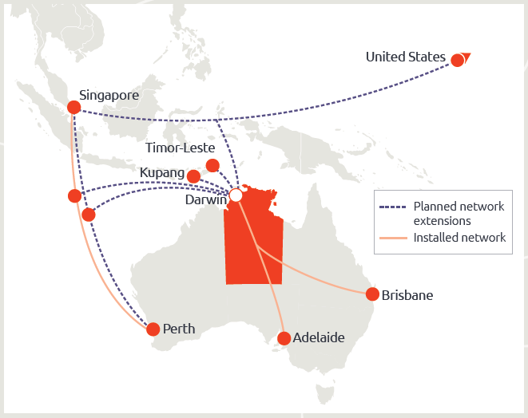

Wishart Estate
The Northern Territory Government has identified Wishart Estate for establishment of an initial Data Centre park, as it:
- Has flexible land parcels to optimize footplates, building heights and engineering services
- Has ample land to allow for expansion
- Supports low rise, low cost data centre construction
- Has climatic conditions that supports a level of free cooling for part of the year
- Is outside of the principle flight paths
- Is above the 1:200-year flood level and outside of the primary and secondary surge zones
- Has a zoning amendable for Data Centre development
- Is close to power infrastructure
- Is midway to the Darwin and Palmerston CBD’s.

Power supply

The Territory
- has the second lowest emissions for power generation in Australia, because of the high contribution of gas and increasing levels of solar in the Territory’s energy mix
- has a Renewable Energy Target of 50% by 2030.

Wishart Estate
- 50 MVA is available and this can increase in three years to 100 MVA following the execution between relevant parties of power supply agreement(s)
- Subject to commercial agreement volumes of power greater than 100MW may be achieved within an agreed timeframe
- A competitive wholesale power tariff is achievable.

Alternate sites
- The Territory is willing to work with proponents to identify alternate sites which are better suited to their business needs
- Both private and crown land available in and around the Darwin area
- It is likely that these sites are undeveloped and would require enabling works prior to development
- Development costs and power pricing will be location specific.
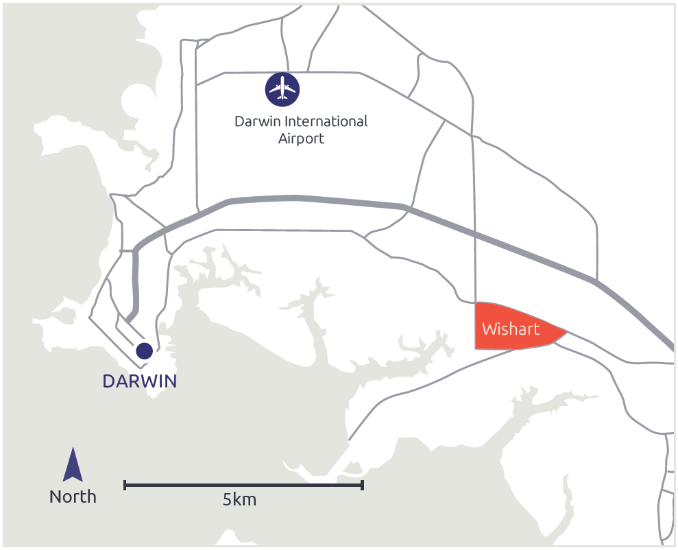

Future power supply
There are numerous renewable projects in different stages of development throughout the Territory. The Territory has some of the highest solar irradiation per square metre making it prime for solar generation.

Australia – ASEAN Power Link (Sun Cable)
- Has proposed a 10GW solar farm with HVDC transmission to Darwin and HVDC subsea cable to Singapore.
- FID is planned for 2023 and the project is to commence operations by 2026 in Darwin and 2027 in Singapore.
- Has the potential for proponents to execute off-take agreements for Darwin Data Centres.

Gas Reserves
- The gas resources offshore are in the order of 30 trillion cubic feet (Tcf)*
- Operators are examining development options for various fields including Petrel; Tern/Frigate; Evans Shoal and Barossa
- Exploration is underway in the world-scale Beetaloo sub-basin (400km south of Darwin) which is estimated to contain gas resources in excess of 500 Tcf
* Australia currently uses 1.6 Tcf of gas per annum

The proponent
The Territory is seeking Data Centre proponents who will contribute to delivering the Territory’s vision of becoming Northern Australia’s most advanced digital economy and Australia’s digital gateway to Asia and beyond.
Proponents will have:
- data centre construction and operational experience
- a demonstrated record of data centre growth
- a vision of what can be delivered now and in the future for the Territory
- to indicate if their proposal requires consideration by the Australian Foreign Investment Review Board
- demonstrated that they are good Corporate/Business citizens; and
- the financial capacity to deliver the project.

The proposal
What is the proponent proposing to develop, including:
- total land parcel size, power required and gross floor area
- development timeline (noting that the location will be available for construction in 18 months)
- number of stages and key drivers for expansion
- critical IT load and translation into power demand
- Project Capex
- Project Opex, including employment opportunities.

The process
The process includes:
- registration by proponent(s)
If the registration is accepted by Territory, the proponent:
- is given access to an EOI information data room
- may submit the EOI Response Schedule.
Following closure of the EOI, the steps include:
- evaluation against the selection criteria
- selection of preferred bids
- negotiation with the preferred bidders.

How to respond to this Expression of interest
For further information and to register for access to the EOI information data room business.nt.gov.au/darwindatacentre
Registrations are open from 17 July 2020 – 25 August 2020.
EOI opens 21 July 2020.
EOI closes at 10:00am Australian Central Standard Time on Tuesday 15 September 2020.
Department of Trade, Business and Innovation
Disclaimer: This document includes information provided by third parties. The information is general in nature and is for information purposes only. The Northern Territory Government makes no representation about the veracity or accuracy of information provided by third parties. You must rely on your own due diligence before proceeding. You should consider seeking independent professional advice. July 2020.
For more information please visit business.nt.gov.au/darwindatapark

