International water
theme park – Darwin
For best reading experience view in outline mode
The Northern Territory Government is seeking private sector investment to develop an international standard water theme park in Darwin. The development will increase the breadth and quality of tourism experiences and may also include other attractions such as entertainment precincts, recreational activities, and food and retail outlets.
This will encourage tourists to visit the Territory and stay longer while also improving the liveability of Darwin and creating jobs.
The NT Government is looking for the best and brightest private sector ideas and proposals to develop the water theme park. The proposal which delivers the greatest value for Territorians will be selected through an open and competitive process.
Government has nominated a site option for the development and will now call for expressions of interest from proponents who will invest in and develop the water theme park.
The development of the water park on the Stokes Hill Waterfront will grow the existing waterfront tourism precinct and provide public access along the foreshore. Other site options proposed by bidders through the process will also be considered.
The project will benefit from the $200 million investment by the NTG in tourism marketing and infrastructure over the next five years and will contribute to the revitalisation of Darwin.

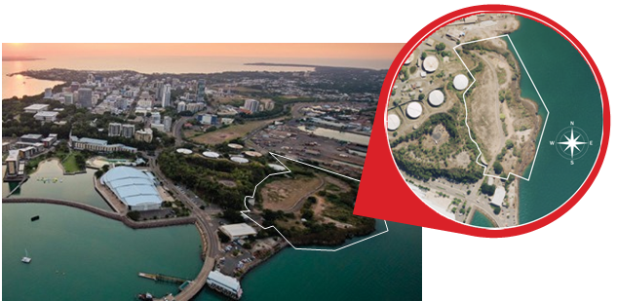

Next steps
The registration period for potential developers commences on Monday 21 May 2018.
The formal Expression of Interest process opens on 4 June 2018. The EOI process will run for approximately 10 weeks, closing 22 August 2018.
The Expressions of Interest will then be assessed by the Territory Government with support from experts and overseen by a probity auditor.
Short-listed proponents will then proceed to a Request for Detailed Proposals phase, before a final developer is selected.
The process to select a preferred developer is expected to be complete in early 2019.
Pending approvals, works on the site could commence in late 2019 or 2020.
Construction is anticipated to take approximately two years.

COMMERCIAL VIABILITY
In August 2017, the Northern Territory Government engaged Pico Play through an open tender process to develop a detailed business case for a world-class water theme park in Darwin.
The business case, completed by Pico Play, assessed the level of market demand for a water theme park, provided an analysis of the most suitable sites and made recommendations on
a process to facilitate and attract private sector investment for the project.
The business case suggests the Darwin Water Theme Park is commercially attractive to a private sector investor to build, own and operate without the need for ongoing support from
the NT Government.
The site permits a range of activities that could be developed with the water park as part of an integrated mixed-use development to maximise commercial sustainability.

Jobs
The detailed business case commissioned by government estimates around 45 direct and 70 indirect jobs will be created during a two year construction period, with around 60 direct and 90 indirect jobs created ongoing during the operational phase.
Additional opportunities may be created through other complementary uses proposed to be co-located with the water theme park e.g. any food or retail outlets.

Enviroment
Similar to the Darwin Waterfront development, the successful proponent will be required to comply with all relevant environmental assessment processes, timeframes and conditions including the rehabilitation of the site for public use.

Funding and investmenet
The Northern Territory Government committed $0.5 million in the 2017/18 budget to prepare the business case needed to progress the project and $1.7 million in the 2018/19 budget to support the competitive process now underway.
Government has offered a parcel of land as a site option to support the development.
The total private investment in the project is expected to be in excess of $50 million.

Enquiries
General enquiries in relation to the project should be emailed to dwtp@nt.gov.au

