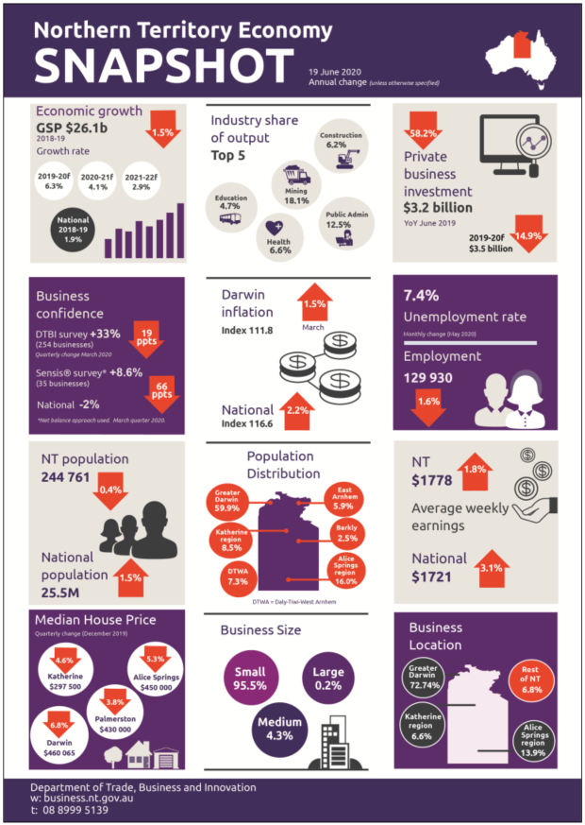
NT Department of Trade, Business and Innovation
t: 08 8999 5139
business.nt.gov.au

