Vision
The Territory is a globally significant critical minerals producing, processing and manufacturing centre

3 Point Plan
- Accelerate exploration for critical minerals
- Support critical minerals projects to commence production
- Grow refining, processing and manufacturing of critical minerals in the Territory.

Current and developing projects
The Territory is a world leader in manganese production, with one of the world’s largest high-grade manganese deposits at Groote Eylandt and further deposits at Bootu Creek. There are a number of other projects with potential to commence production.

Lithium
Grants Lithium Project, Core Lithium Ltd
Resource: 8.6 Mt @ 1.33% lithium oxide Capex: $54M
Environmental assessment lodged
Proposed Schedule: 2019/20
- proposed open cut mining operation
- mineral lease granted Jan 2019

Vanadium
Mount Peake, TNG Ltd
Resource: 160.4 Mt @ 0.28% vanadium pentoxide, 5.3% titanium oxide and 23% iron.
Capex: Stage one $853M
Environmental assessment complete
Proposed Schedule: Q3 2021
- one of the world’s largest vanadium-titanium-iron resources
- TIVAN® processing plant planned in Darwin
- high-purity vanadium electrolyte, with potential to supply the Vanadium Redox Battery sector

Copper
Jervois, KGL Resources Ltd
Resource: 25.2 Mt @ 1.53% copper and 29.2 g/t silver.
Capex: $190M
Environmental assessment lodged
Proposed Schedule: Q2/3 2020
- open cut and underground operation
- 12+ years lifespan

Rare Earths
Nolans, Arafura Resources Ltd
Resource: 56 Mt @ 2.6% rare earths, 11% phosphate and0.02% uranium oxide
Capex: US$726M
Environmental assessment complete
Proposed Schedule: Q1 2022
- one of the world’s largest neodymium- praseodymium (NdPr) deposits
- potential to produce around 10% of the global demand for NdPr magnet feed
- processing planned onsite
The Territory has numerous other critical minerals projects at various stages from exploration through to near production, including for copper, cobalt, tungsten, zircon and ilmenite.
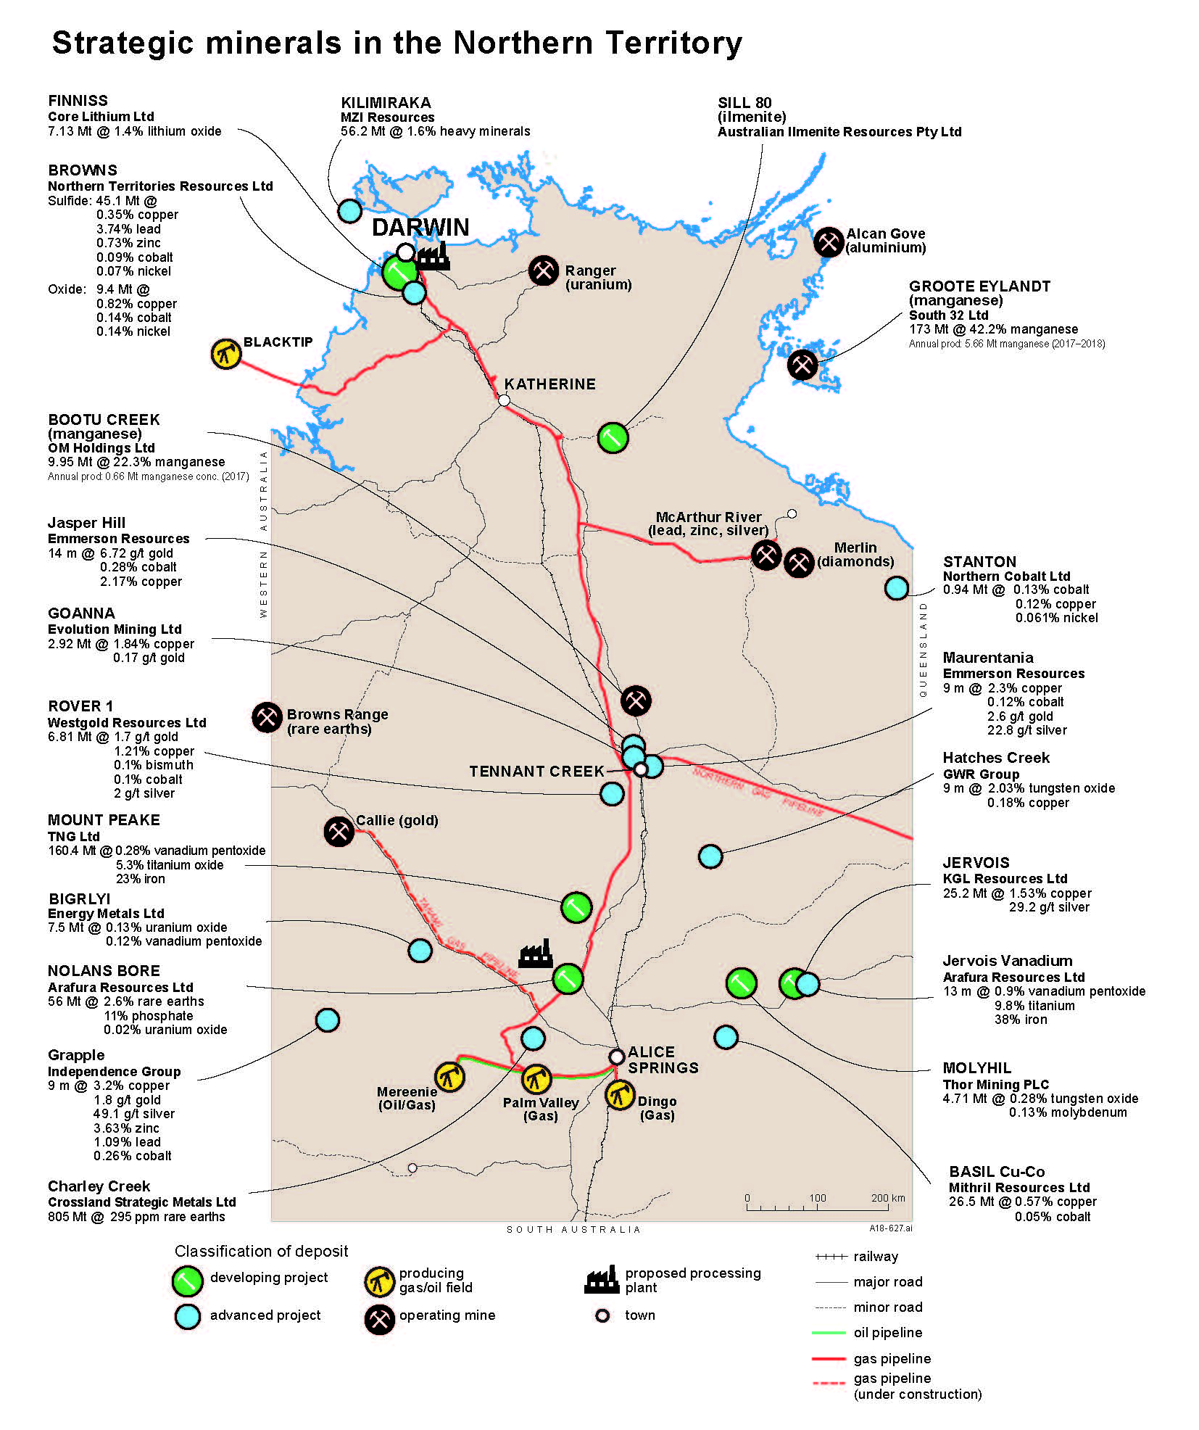

The Territory’s critical minerals
- cobalt
- copper
- lithium
- titanium
- manganese
- rare earths
- tungsten
- vanadium
- zircon

Critically important minerals
Critical minerals are mineral resources that are strategic to the global economy, particularly for new and emerging technologies.
These currently include rare earths and other high value technology metals, used for making batteries, electric vehicles, mobile phones, high-definition screen displays, solar panels, medical equipment and for military technology use.
The Territory is focused on increasing its participation in the latter stages of the critical minerals value chain and is actively seeking investment to support this goal.
Value-add opportunities | Export opportunities
Mining | Unrefined minerals
Refining | Refined minerals
Processing | Metals
Manufacturing | Product components
End user products | Product exports

The Territory Government is collaborating with the Australian Government, and other states and territories on the development of the National Critical Minerals Work Program and is developing a comprehensive Territory Minerals Industry Development Strategy.

Investment opportunities
- Exploration stage projects to define resource and demonstrate economic viability
- Critical minerals projects with most approvals in place
- Domestic refining, processing and manufacturing technologies and facilities

Land and infrastructure
Industrial land is available at Middle Arm for the minerals processing and manufacturing industry. Darwin is linked by a transcontinental rail service, national highway, international airport and supported through the nearby Port of Darwin at the East Arm Logistics Precinct.
Land available for industrial development at Middle Arm, Elrundie Peninsula and support infrastructure at East Arm Logistics Precinct.

Territory Government support
A number of attractive services and support mechanisms to grow private sector investment and create jobs:

Resourcing the Territory Initiative
$26 million initiative providing pre-competitive geoscience, investment attraction and exploration stimulus programs designed to increase exploration activity and success rates, and underpin the long term sustainability of the resources sector.

Major Project Status Policy
Support the timely and efficient delivery of such projects through consistent and efficient government processes.

Local Jobs Fund
$89 million co-investment fund to accelerate significant projects through loan guarantees, business investment concessional loans, equity co-investment and grants.

Market Led Proposals Policy
Generate, advance and promote development of innovative private sector proposals to advance economic development through a fair and transparent process.

Contact

Northern Territory Geological Survey
Department of Primary Industry and Resources Northern Territory Government, Australia
Phone: +61 8 8999 1385
resources.investment@nt.gov.au
resourcingtheterritory.nt.gov.au

Strategic Infrastructure and Projects
Department of Trade, Business and Innovation Northern Territory Government, Australia
Phone: +61 8 8999 6167
sip@nt.gov.au
business.nt.gov.au

