Contents
Vision 2
The opportunity 2
Why the Territory 2
National Hydrogen Strategy 2
The renewable hydrogen opportunity 3
Production 3
Transport and storage 3
Existing and potential applications 3
A sustainable water source is critical to the success of a hydrogen industry 4
Renewable hydrogen production and use 5
Future demand 5
Global forecasted hydrogen demand (mtpa) 6
Our context 6

Vision
The Northern Territory’s vision is to be recognised as a leader in the world transition to renewable hydrogen (H₂).
The Territory’s aspiration is to be an international scale renewable hydrogen technology research, production and downstream manufacturing centre.

The opportunity
The Territory has embraced a target of net zero emissions by 2050 and hydrogen can play a central role in its realisation.There is an opportunity for the Territory to position itself at the forefront of this developing industry. This Strategy articulates the potential hydrogen opportunities, the Territory’s competitive advantages and how the Territory can leverage these to be a centre of hydrogen technology research, production and use in Australia.

Why the Territory
The Territory is well placed to achieve its hydrogen vision.
- With significant tracts of land with high solar irradiance, the Territory is highly suited to large-scale solar renewable hydrogen developments.
- The Territory’s geographical proximity to Asia, with the closest Australian capital city port to key potential export markets in China, Japan and Korea, the deep sea port at Darwin offers timely delivery and lower transportation costs.
- An established world-scale energy production and export industry underscores the Territory’s credentials as a competitive location for private investment with demonstrated capacity to deliver large-scale energy export projects.
- Commitment to facilitating and supporting investment which delivers its net-zero emissions vision.
To this end, the Territory has adopted an adaptive strategy that is consistent with and is to be implemented in parallel with Australia’s National Hydrogen Strategy.

National Hydrogen Strategy
National cooperation and coordination will be required if Australia is to realise hydrogen’s full potential.
The Council of Australian Governments (COAG) Energy Council’s National Hydrogen Strategy, published in November 2019, has been developed to position Australia as a major player in global hydrogen by 2030.
The National Hydrogen Strategy emphasises the broad spectrum of pathways that could unfold for the development of a world-scale hydrogen industry. The timing and scale of a hydrogen industry is highly dependent on the commercialisation of hydrogen technology and international demand for the commodity.
To facilitate the development of a national hydrogen industry, hydrogen hubs – clusters of large-scale demand – have been identified as the catalyst to scale up Australia’s domestic industry to become a global competitor.

The renewable hydrogen opportunity
As the international community searches for innovative ways to reduce greenhouse gas emissions, demand for reliable, flexible and zero emissions energy solutions like hydrogen are growing.
Hydrogen is currently used predominantly as a chemical input for industrial processing and manufacturing, but has the potential to be adapted to a wide variety of applications.
In particular, hydrogen has significant potential as a zero emissions energy store and carrier.Hydrogen:
- can be produced with zero emissions;
- is energy dense and can be stored and efficiently transported; and
- when converted to heat energy through combustion or to electricity in a fuel cell, does not produce any greenhouse gas emissions.

Production
Hydrogen generally does not exist naturally in its pure form so must be manufactured from compounds that contain it. Renewable hydrogenis produced by electrolysis of water using electricity from renewable energy sources such as solar. The production of renewable hydrogen results in no greenhouse emissions.

Transport and storage
Hydrogen can be transported as a gas in pipelines; or cooled and compressed into a liquid and stored in tanks and transported by trucks, trains and ships.
Hydrogen can also be stored and transported as ammonia (NH₃) in liquid form under normal temperatures and pressures. Hydrogen gas can be easily converted to liquid ammonia and back to hydrogen gas with relatively minor energy loss.
Hydrogen’s ability to be stored and transported makes it an exportable commodity, opening up opportunities for hydrogen produced in renewable resource-rich locations such as the Northern Territory to be traded domestically and internationally in large quantities.

Existing and potential applications
Current world demand for hydrogen in its pure form is about 70 million tonnes per annum (mtpa), mostly for oil refining and ammonia, methanol and steel production.

A sustainable water source is critical to the success of a hydrogen industry
Water is valuable for social, environmental, cultural and economic outcomes.
The value of water is enabled through policies and management frameworks which support sustainable and productive use now and for the future. The Northern Territory Government is committed to ensuring that the Territory’s water resources are managed prudently to achieve these outcomes.
Hydrogen can be produced from various sources of water, including waste water and sea water. A renewable hydrogen supply chain will require economically viable water processing and refining to be sustainable.

Today, the vast majority of hydrogen is produced from fossil fuels and results in material greenhouse gas emissions.
Displacing traditional (emissions intensive) hydrogen in refining and chemical manufacturing with renewable hydrogen represents just one of many opportunities to reduce greenhouse emissions through hydrogen.
Renewable hydrogen can also be used in a variety of other applications as an energy carrier and can displace greenhouse gas emitting fuels such as petrol and diesel.
Heating – Hydrogen can be used in a similar way to natural gas for heating homes, cooking and for large-scale industrial heating applications.
Transport - Hydrogen can be used to power fuel cells in electric vehicles. Due to its high energy density, hydrogen may be particularly suited to commercial and long-haul transport as hydrogen fuelled vehicles are able to carry heavier loads and travel longer distances than current battery powered electric vehicles.
Replacing a medium-sized diesel or petrol powered car with a renewable hydrogen powered vehicle would avoid 20 kilograms of carbon dioxide equivalent (CO₂-e) emissions per 100 kilometres driven.
Stationary electricity – Hydrogen electricity generation technologies are capable of producing electricity on demand to support the security and reliability of electricity systems.
Storing renewable energy in the form of hydrogen enables excess energy generated from intermittent renewable sources to be captured and used at times when these sources are not available.
For every megawatt hour of Australian grid electricity displaced by renewable hydrogen electricity generation, 750 kilograms of CO₂-e emissions would be avoided.
Hydrogen may be particularly suitable to support renewable energy generation in remote area power systems where it could displace high cost liquid fuels such as diesel.

Renewable hydrogen production and use
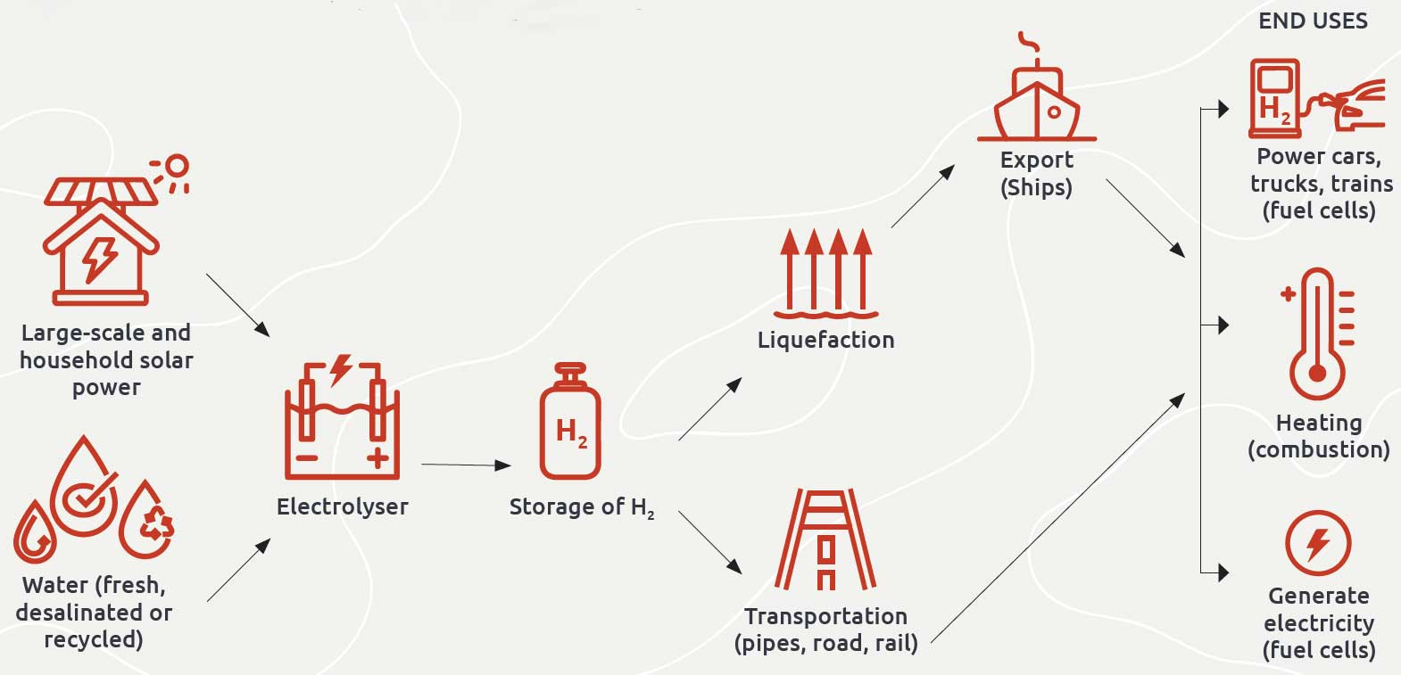

Future demand
Due to its early stage of development, hydrogen currently has relatively high costs and lacks the supporting infrastructure of fuels more widely used such as natural gas, petrol and diesel. However, hydrogen’s potential as a zero greenhouse emissions energy carrier has attracted significant international attention.
Signatories to the 2015 Paris Climate Agreement agreed to undertake ambitious efforts to combat climate change and committed to keep a global temperature rise to well below 2 degrees Celsius above pre-industrial levels.
Many countries have already signalled interest in large-scale hydrogen investment to support their greenhouse emissions reduction efforts. Some of Australia’s largest trading partners - Japan, Korea and China - have committed to using hydrogen to decarbonise their energy systems. There is a growing international consensus that largescale and rapid deployment of hydrogen technology could emerge from 2030 onward.
In this context, future demand for hydrogen will depend on international efforts to decarbonise, reductions in the cost of hydrogen production and ancillary technologies such as fuel cells, and development of competing low emissions-compatible technologies like batteries.
Renewable energy costs continue to decline and the technologies are being incorporated throughout energy supply chains. The decline in renewable energy costs is improving the commercial prospects for wide-scale adoption of renewable hydrogen as an energy carrier.
However, as an energy carrier, hydrogen is competing with batteries and if there are significant improvements in the capability and cost of battery technology, near universal adoption of batteries for energy storage could delay the potential for wide-scale adoption of hydrogen.
Demand projections for the National Hydrogen Strategy indicate that global demand for hydrogen could increase rapidly after 2030 to as much as 300 mtpa by 2050. However, under a low demand scenario, demand growth would be more subdued and increase only to about 100 mtpa.

Global forecasted hydrogen demand (mtpa)
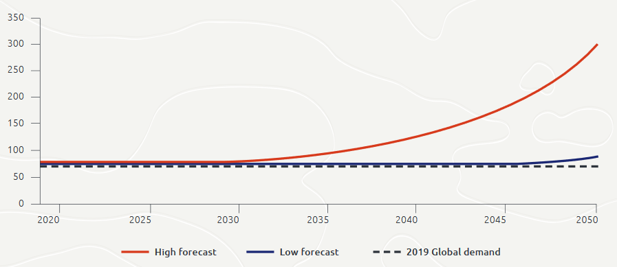
Source: Based on the Australian and Global Hydrogen Demand Growth Scenario Analysis prepared by Deloitte in 2019 for the COAG Energy Council.

Our context
Many countries lack the natural resources (for example, solar and wind) to produce renewable energy to a scale required to support their economies’ transition to low emissions.
These countries are looking internationally for solutions to meet their energy needs while fulfilling greenhouse gas emissions reduction targets.
Hydrogen production is capital and technology intensive, requiring significant investment in infrastructure for production, storage and transportation.
Although hydrogen production is an existing industry, to supply the potential scale of future demand and adapt to the emerging uses for hydrogen as a fuel, further largescale infrastructure development will be required.
There is the potential for hydrogen production, export and adoption to generate significant jobs and investment in the Territory, much of which could be in regional areas. Further, in addition to commodity exports, the development of a renewable hydrogen industry could result in valuable opportunities for the Territory to export expertise and technology.

The Territory’s hydrogen advantage
The Territory has significant competitive advantages in the development of renewable hydrogen hubs. With extensive renewable energy resources, enabling infrastructure, and expertise developing a world-scale energy production and export industry, the Territory is well positioned to capitalise on emerging hydrogen opportunities.

Supportive business environment
The Territory Government is committed to attracting private investment to establish and build local industries, and is in active discussions with private sector proponents to develop hydrogen projects in the Territory.
The Territory is seeking investment and collaborative partnerships to develop projects that align with this Hydrogen Strategy.
Through its Market-Led Proposals Policy, the Territory Government welcomes commercial proposals initiated and submitted by private or non-government sector proponents, to deliver infrastructure and/or services that will provide tangible benefits to the community.
The Territory Government also assists large projects that align with the Territory’s long-term interests through the awarding of major project status. These projects benefit from efficient and consistent government processes through a central and single point of contact.
Major project status also means focussed effort is provided to support proponents through government regulatory approval processes.

Energy expertise
The Territory’s workforce has specialised energy expertise, developed through the establishment of Darwin as a world leading energy production and export hub.
The Territory’s two LNG plants, Darwin LNG and Ichthys LNG, together have nameplate capacity to produce 12.6 mtpa and have established the Territory as a world-scale energy producer.
Charles Darwin University, with campuses in Darwin, Alice Springs and Katherine, is the home of the Energy and Resources Institute, the North Australian Centre for Oil and Gas, and the Centre for Renewable Energy which provide multidisciplinary research, training and industry leadership.
The Territory is building momentum in the renewable innovation space. The Desert Knowledge Australia Solar Centre is the largest multi-technology solar demonstration facility in the southern hemisphere and the Intyalheme Centre for Future Energy is enhancing renewable energy capability by delivering collaborative projects that conceptualise and validate future grid options (technologies, systems, networks, commercial and market partnerships); being a conduit (facilitating connections, providing advice, linking projects and people); and, sharing knowledge (community education and engagement, disseminating targeted information to enhance renewable energy capability).
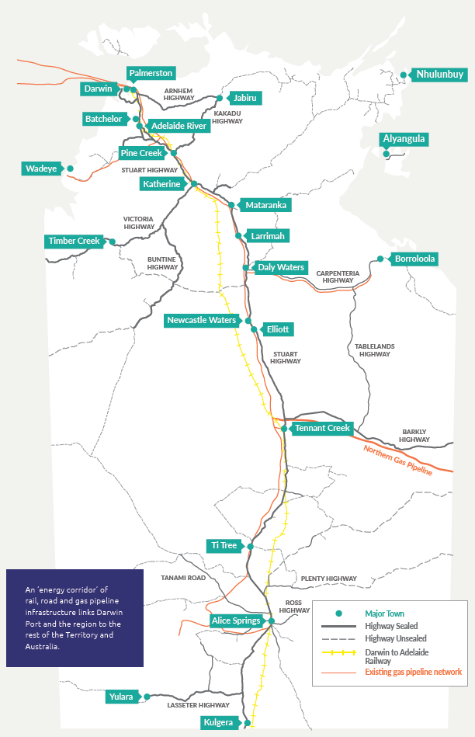
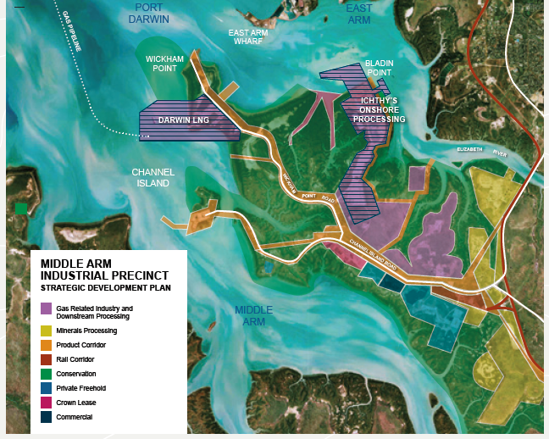

Enabling infrastructure
The Territory has multi-user export infrastructure suitable to provide a low cost base to support large-scale hydrogen export developments.
Darwin’s deep sea port is five times the size of Sydney Harbour and is strategically located adjacent to land zoned for industrial development. This land is already home to the Darwin LNG Plant and the Ichthys Onshore LNG Processing Facility.
The Middle Arm Industrial Precinct has an extensive product corridor network for the transport of goods and the transmission of utilities, gas and feedstock.
Darwin Port and the Middle Arm Industrial Precinct are located 15kms from the Darwin CBD, making them easily accessible to supporting industry and workforce. Proximity to a capital city provides access to urban infrastructure and services that are not available in other remote port locations, including to an international airport.
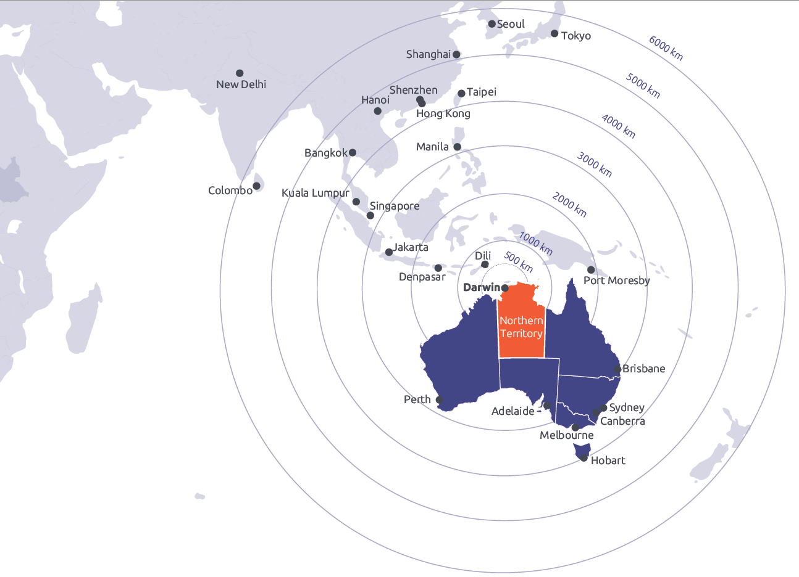

Proximity to export markets
Export markets will be key to development of Australia’s hydrogen industry.
To ensure that Australia is internationally competitive, efficient hydrogen trade routes will be essential to meeting international demand.
The Territory is physically situated in close proximity to international export markets and offers the shortest and quickest route from Australia to potential hydrogen markets throughout Asia.
Through its establishment as a world-scale energy production and export hub, the Territory has developed trade relationships with international neighbours with commitments to develop hydrogen demand including Japan, Korea and China.
“International competition between Australian hubs and hydrogen export terminals in other countries is likely to lead to the success of the lowest cost producers with low cost shipping routes to markets in Asia and further afield.”
- Australian Hydrogen Hubs Study, COAG Energy Council Hydrogen Working Group

Abundant renewable resources
For a renewable hydrogen industry to be economically sustainable, producers must have access to cheap, abundant and reliable renewable energy resources.
The Territory has some of the best renewable resources in the world with high levels of solar irradiance.
Further, the Territory’s size provides opportunities to develop large-scale renewable energy generation projects.
There is already a high level of interest in developing the Territory’s solar resources for export.
The Territory Government has awarded major project status to the 10 Gigawatt Sun Cable solar farm and battery storage facility proposed near Tennant Creek in the Barkly region. The Sun Cable project proposes to link the premium solar resources of the Territory’s Barkly region through high voltage direct current cable to Darwin and on to Singapore. Sun Cable is an example of the innovative opportunities that are emerging for solar energy export.

Large-scale project capabilities
Hydrogen production, transport and storage infrastructure will need to be built large enough to fully capitalise on the benefits generated from scale economies. The development of large-scale hydrogen hubs, will be key to bringing hydrogen production costs down.
While the Territory already has significant enabling infrastructure, hydrogen-specific infrastructure requirements and potential expansions of current capacity to meet production needs may be required.
With a highly-skilled workforce, the Territory has demonstrated capacity for large-scale facility construction and operation and has developed local infrastructure and supporting supply chains.

The Territory’s approach
To achieve its vision to become a leading producer of renewable hydrogen, the Territory must be pragmatic and take advantage of the available and emerging opportunities, playing to its strengths and adapting its approach as technology and market conditions evolve.
The Territory acknowledges the considerable current uncertainty around the future of renewable hydrogen in the context of developments in other competing renewable energy technologies. The relative speed at which the competing low emissions technologies develop will directly affect the opportunities to be realised from hydrogen.
There are different development pathways that could emerge, and building a new industry demands vision, will take time and requires patience.
The Territory’s competitive advantages lend themselves to developing renewable hydrogen export hubs serving both potential demand from its Asian trading partners and supporting ancillary domestic hydrogen use and downstream manufacturing.
Local industry leveraging of renewable hydrogen production, in the early stages of developing a new hydrogen industry, will provide benefits for Territorians through employment opportunities and economic diversification. Hydrogen will also contribute to the Territory’s own decarbonisation efforts, providing opportunities for industry to switch to a more sustainable energy source.
“In order to create investor confidence, the more economic ports which have existing hydrogen commitments and strategies, or are in the process of developing same, will need to have clearly stated investment plans with realistic time frames, and exhibit support from both local communities and State and Federal Governments, so that inefficient planning barriers are minimised.”
- Australian Hydrogen Hubs Study, COAG Energy Council Hydrogen Working Group

Early opportunities for the adoption of modest-scale renewable hydrogen in the Territory could include fertiliser production, long haul heavy vehicle transport, and in stationary electricity production in remote power systems.
The Territory’s numerous remote isolated communities and mining operations could adopt hydrogen to provide supply reliability in support of intermittent renewable energy sources.
Hybrid solar and hydrogen powered microgrids in isolated systems could reduce costs and emissions by displacing expensive and high emissions diesel-fired electricity generation. The expense of diesel-fired generation in remote areas may incentivise early adoption of hydrogen.
The Territory will be able to draw on extensive experience in remote service delivery to facilitate early trials of hydrogen technologies in isolated systems.
Long haul and heavy vehicle transport industries have not yet experienced success with electrification that is reforming other industry sectors. Hydrogen adoption may offer a more accessible pathway for industry efforts to decarbonise.
Support for the development of a Territory renewable hydrogen hub from all levels of government will be essential to attracting the needed investment.
However, the in-principle support of governments will not be enough to achieve the Territory’s vision and a number of actions are necessary to support investment interest and confidence.
The Territory’s adaptive strategy, consistent with the National Hydrogen Strategy, is to assess and minimise barriers, develop local industry capabilities and supply chains and maximise opportunities to facilitate the development of renewable hydrogen hubs.

A five point hydrogen plan

1 Local Industry Development
To achieve the Territory’s renewable hydrogen vision the Territory will focus on preparing local industry capabilities, logistics and supply chains to facilitate the adoption of renewable hydrogen. Local industry adoption of hydrogen and development of hydrogen-based industries will provide opportunities for the diversification of the Territory’s economy, generate job opportunities and grow the population.

Actions
- Incorporate the hydrogen industry within the Territory’s economic development strategies
- Map and analyse the hydrogen industry ecosystem and supply chain to enable early planning and coordinated effort in establishing enabling infrastructure requirements
- Harness the Territory’s energy production and export experience to grow expertise in hydrogen production and supportive supply chains
- Work with industries such as transport, mining and industrial manufacturing to understand opportunities for the Territory to integrate hydrogen use

2 Resource Management
To harness potential opportunities, the Territory will investigate how to optimise its resources and infrastructure to facilitate hydrogen industry development. Having a clear and comprehensive understanding of how hydrogen can be integrated into the Territory economy will ensure that local industry at all stages of the supply chain are prepared for the establishment of a new hydrogen industry in the Territory.

Actions
- Work with the Australian Government to complete the National Hydrogen Infrastructure Assessment
- Secure access to transport and utilities corridors to provide project proponents certainty for energy export infrastructure
- Define the potential role of hydrogen in the Territory Government’s target of net-zero emissions by 2050
- Incorporate potential hydrogen industry demand in the Territory Government’s water strategies and plans to achieve socially, environmental and economically beneficial outcomes

3 Grow and Harness Demand
The Territory’s proximity to Asia, established trade partnerships and demonstrated ability to deliver world-scale energy export projects position the Territory as an attractive export hub. Although large-scale hydrogen export is a longer term aspiration, if the Territory is to fully capitalise on its competitive advantages, early preparation and planning will be essential. The Territory and industry need to take action to grow and harness demand for hydrogen to maximise the local use and international export potential for the resource.

Actions
- Participate in domestic and international hydrogen forums and conferences
- Promote the Northern Territory Renewable Hydrogen Strategy to existing and prospective trade partners
- Develop case studies and pilots for hydrogen application in the Territory, to inform and provide opportunities for hydrogen researchers and technology demonstrators
- Assess the future potential for hydrogen in the Territory’s remote power systems to support reliability of supply from intermittent renewable energy sources
- Continue to enhance trade relationships with key trading partners and promote and secure export opportunities

4 Support Innovation
As renewable hydrogen technologies are continuously developing, new ways of researching, trialling and adapting emerging technologies to the Territory context will be essential to ensure that the Territory remains at the forefront of and optimises hydrogen opportunities. The Territory will support innovation and facilitate expansion of local knowledge and expertise in hydrogen.

Actions
- Encourage trials of hydrogen technologies in applications high on the hydrogen cost curve, such as remote area power systems including remote work sites and commercial and long-distance transport
- Explore opportunities for demonstration projects that increase community confidence and understanding of hydrogen technologies
- Establish a Hydrogen Working Group, comprising representatives of key government agencies, and Industry Reference Group, comprising industry leaders with an interest in hydrogen, to revise and implement this adaptive Northern Territory Hydrogen Strategy

5 Responsive Regulation
To achieve the Territory’s renewable hydrogen vision the Territory will focus on preparing local industry capabilities, logistics and supply chains to facilitate the take up of renewable hydrogen production. Local industry uptake of hydrogen and hydrogen related products will provide opportunities for the diversification of the Territory’s economy, increase job opportunities for Territorians and grow the population.

Actions
- Review existing legislation, regulations and standards as needed to enable legal frameworks that can support hydrogen safety and industry development
- Coordinate with the Commonwealth and other Australian jurisdictions to develop best practice regulatory frameworks for hydrogen and seek national regulatory consistency
- Address unnecessary barriers to the development of hydrogen ready capabilities associated with current planning and regulatory approval mechanisms
- Develop technology neutral reliability and security services procurement frameworks for the Territory’s regulated electricity systems and consider the potential for grid-connected electrolysers to provide these services
- Build hydrogen safety knowledge and capacity within government and industry bodies

Community engagement
Developing a new industry is critically dependent on the support and engagement of the local community. Territorians need to be confident in the safety and sustainability of a local hydrogen industry, and be persuaded of the significant opportunities which can come from integrating hydrogen-based energy throughout the economy.
The Territory will communicate industry developments and strategic plans, and engage with local communities to understand and address environmental, safety and economic concerns through an evidence based approach. The Territory will continue to participate with the Commonwealth and other jurisdictions in the development of the national community education program to provide clear and accessible information about risks, benefits and safe use.
business.nt.gov.au/hydrogen-strategy
Office of Sustainable Energy
Department of Trade, Business and Innovation
Northern Territory Government
e: sustainableenergy.dtbi@nt.gov.au
July 2020

