The opportunity
The Territory Government is seeking expressions of interest from suitably qualified parties (Proponents) to develop and operate a seniors’ lifestyle accommodation village in Alice Springs, Australia (the Project).
The expression of interest process will provide a flexible framework to deliver a high quality and commercially sustainable project.
The expression of interest is the first stage of a two-stage competitive process to facilitate private sector delivery of the Project and will be followed by a Request for Detailed Proposals.
The Territory Government encourages qualified developers, landowners, operators and investors to submit innovative and compliant proposals for this unique investment opportunity.

Alice Springs and Australia’s Northern Territory
The Northern Territory occupies about one-sixth of Australia’s total land mass, with a population of about 245,000 and is home to some of the natural world’s most unique and exciting destinations.
The Northern Territory is diverse - with landscapes ranging from the red sandy desert of Alice Springs and Uluru/Ayers Rock and the golden plains of Tennant Creek, to the savanna woodlands surrounding Katherine and the lush green tropics of Darwin and Kakadu.
Alice Springs is the second largest urban centre in the Northern Territory, with a population of around 24,753. It is the geographic centre of Australia positioned half-way between Darwin and Adelaide, (1500km in each direction), and is the gateway to iconic Uluru-Kata Tjuta National Park, home of Australia’s most famous natural attraction, Uluru.
The township is a place rich in natural and cultural heritage and a major economic hub servicing the southern region of the Northern Territory, as well as remote areas of South Australia, Western Australia and Queensland. It plays an important role in relation to pastoralism, transport and logistics, tourism and defence. Above all it is the centre of regional community providing civic, government and social services for a particularly large region.
Alice Springs provides for the community a range of retail and entertainment opportunities; hospital and allied health services; community and support services and has great connectivity to the rest of Australia by road, rail and air services.

The Territory, Australia
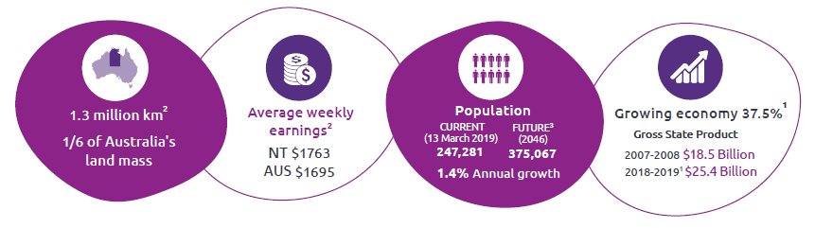

Why Seniors’ Lifestyle Accommodation in Alice Springs

Alice Springs seniors population
 | 2006 | 2011 | 2016
55-64 years | 2789 | 3497 | 4034
65-74 years | 1042 | 1298 | 1730
75-84 years | 473 | 505 | 639

Existing facilities in Alice Springs
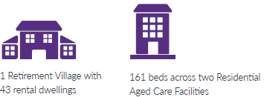

The market for the Alice Springs Seniors’ Lifestyle Accommodation Project
The NT Population Growth Strategy 2018-28 acknowledges that pre-retirees and seniors are the fastest growing group in the Territory’s population, yet research indicates a progressively larger group in this age bracket is migrating out of the Territory each year. In addition to livelihood and lifestyle opportunities, planning transition to retirement and the availability of quality and affordable seniors’ lifestyle accommodation will help the Territory retain this important population segment.
Senior Territorians have clear expectations around specifically-designed residential accommodation options and are becoming more discerning and sophisticated about the choices available to allow them to live independently within a safe community environment, with access to increasing levels of care and community support as they age.
In 2017, KPMG was engaged by the Department of Trade, Business and Innovation to:
- investigate traditional and emerging senior accommodation models
- undertake market analysis through desktop investigations and consultations with stakeholders, local and Territory Governments.
The key findings of the KPMG Report for the Alice Springs area included:
- a current under-supply of senior accommodation
- sufficient residential aged care supply
- target market
- key stakeholder insights
The Territory Government has prepared an Information Memorandum on the KPMG report. The Information Memorandum will be made available to qualified Proponents (refer to the Registration Section on page 6).

Project location
The Territory Government has identified a potential site for the development of a seniors’ lifestyle retirement accommodation, located only 2.5 kms from the Alice Springs Central business district (the Government Site).
The Government Site (Lot 10019, 15 Irrampenye Street) Town of Alice Springs is situated on the northern side of the spectacular MacDonnell Ranges in the premier residential area of Mount Johns. Within very close proximity is one of the world’s top ten desert 18 hole golf course and an international standard entertainment complex.
The Government Site is a 5.58 hectare Crown land site that was formerly designated as Stage 2 of the Mount Johns land release. Under the Indigenous Land Use Agreement with the Lhere Artepe Aboriginal Corporation, native title has been extinguished.
Equally, the Territory Government will consider privately owned sites identified by proponents that may suit individual proposals.
Further information in relation to the Government Site will be made available to interested parties which have registered (refer to Registration, page 6).

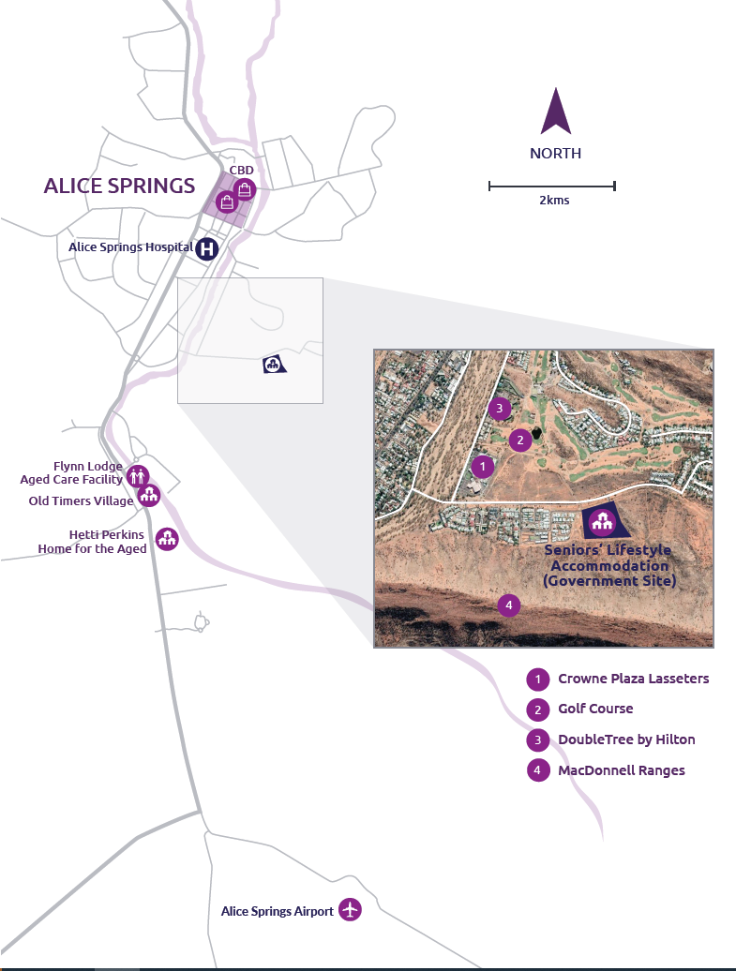

Vision
The Territory Government’s vision is for the provision of purpose-built housing options in a safe community environment. Senior Territorians who live independently in their own home will remain in the Territory and be able to transition into appropriate accommodation by ‘downsizing’ or ‘rightsizing’ if they wish.
The Territory Government is also interested to ensure that the operating structure for delivery of such residences maximises consumer protections.
Proponents will undertake their own due diligence of the Project to determine if it will be a horizontal and/or vertical development; the number and type of accommodation; the price points, the delivery model; and identify the site. In addition, Proponents can also determine if the retirement community is to be co-located with residential aged care facilities for continuity of care; and/ or small scale commercial, retail and community uses (such as childcare, medical and professional services). However, the Project is required to contain a retirement living component.

Your proposal
The Territory Government invites proposals which address the Territory Government’s vision for the Project and which demonstrate a clear understanding of the Northern Territory Government’s following objectives:
- will result in more senior Territorians choosing to live and remain in the Northern Territory following retirement, by broadening the range of quality accommodation choices available to retirees
- contributes to Alice Springs attractiveness as a retirement location by providing modern community living appropriate for aging in place and suited to the local environment and demographics
- respects and recognises Aboriginal culture, heritage and the environmental setting
- delivers an operating framework which maximises consumer protections and preserves value for Senior Territorians
- is sustainable in terms of the financial and commercial model under which it is delivered.
This EOI Invitation represents the first stage in the process and the purpose is to raise awareness of the opportunity and seek EOIs from capable parties.
If following the EOI process, suitably capable entities are identified, the Territory Government may approach shortlisted proponents to submit detailed proposals. The Detailed Proposals process will involve more detailed information being requested through binding bids.

Project timelines
The Territory Government is keen to progress the Alice Springs Seniors’ Lifestyle Accommodation Project. Indicative timelines for the EOI and next phases are:
Project phases | Key dates
EOI registration opens | 21 April 2020
EOI opens | 24 April 2020
EOI registration closes | 15 May 2020
EOI closes | 29 May (10.00am ACST) 2020
EOI evaluation complete | July 2020
Detailed proposals process commences | July 2020
Detailed proposals process closes | December 2020
Preferred proponent announced | Q1 2021

Registration
Interested parties will need to register through business.nt.gov.au/aliceseniors in order to submit an EOI.
The Territory Government will satisfy itself that any interested party seeking to register is a bona fide Proponent and is likely to deliver the project. The Territory Government may seek further information from the interested party that it deems necessary and conduct such due diligence checks as it seems fit.
Parties registering interest will be advised of the outcome of their application within three business days of registering.
The Territory Government reserves the right in its absolute and sole discretion to accept or reject registration applications.
Additional information about the EOI and the Project will be made available to Proponents that have registered their interest in the Project and have been accepted by the Territory Government as qualified Proponents. The additional information available includes:
- details of what the Territory Government seeks from Proponents through the EOI process
- guidance on the evaluation criteria that will be used to assess EOI proposals
- the Information Memorandum.

Lodgement of EOI and enquiries
Proponents will need to complete and lodge all necessary EOI documentation by no later than 10.00am (Australian Central Standard Time) on 29 May 2020.
Proponents will be able to submit enquiries through the website business.nt.gov.au/aliceseniors
General enquiries in relation to the Project should be emailed to seniorsaccomm@nt.gov.au
Department of Trade, Business and Innovation
Disclaimer: This document includes information provided by third parties. The information is general in nature and is for information purposes only. The Northern Territory Government makes no representation about the veracity or accuracy of information provided by third parties. You must rely on your own due diligence before proceeding. You should consider seeking independent professional advice. Version April 2020.
For more information please visit business.nt.gov.au/aliceseniors

Australian Bureau of Statistics, Catalogue Number 5220.0
NT Department of Treasury and Finance
KPMG 2017 Report

